Assignment 04:

Name: Kadiyala Naresh

Rg.no.: 192110312

Course: object oriented C++

Code: DSA0163

1. Write a C++ program to implement Method overriding with your own application

#include<iostream>

using namespace std;

class B;

class A

{

public:

int a;

A()

{

a=10;

}

friend void sub(A,B);

};

class B

{

public:

int b;

B()

{

b=20;

}

friend void sub(A,B);

};

void sub( A A1, B B1)

{

cout<< A1.a-B1.b;

}

int main()

{

A t;

B s;

sub(t,s);

return 0;

}

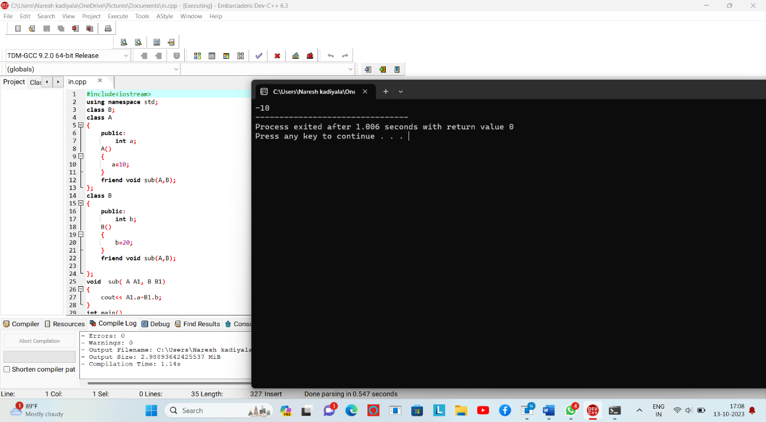

‘

2.)Write a C++ program to implement friend function

#include<iostream>

#include<string>

using namespace std;

class person

{

public:

string name;

void get()

{

cout<<"enter person name:"<<endl;

cin>>name;

}

virtual void work()

{

cout<<name<<" my work is developer"<<endl;

}

};

class employee: public person

{

public:

string nam;

void go()

{

cout<<"enter employee name"<<endl;

cin>>nam;

}

void work()

{

cout<<nam<<" my work is tester"<<endl;

}

};

class manager: public person

{

public:

string namm;

void set()

{

cout<<"enter manager name:"<<endl;

cin>>namm;

}

void work()

{

cout<<namm<<"my work is managing details"<<endl;

}

};

int main()

{

person \*d,c;

employee a;

manager b;

a.go();

b.set();

c.get();

d=&a;

d->work();

d=&b;

d->work();

d=&c;

d->work();

}

